Day 31 - 104608492 - Shirisha Perapagu

DynamoDB - Day31

Server
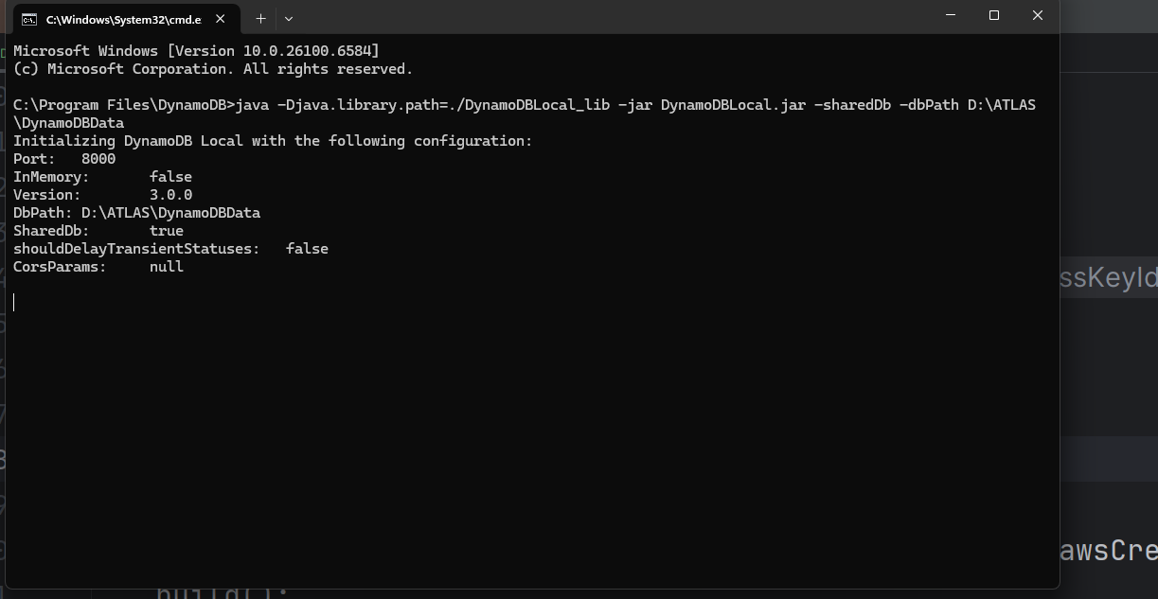

Task 01
Create table Employees01
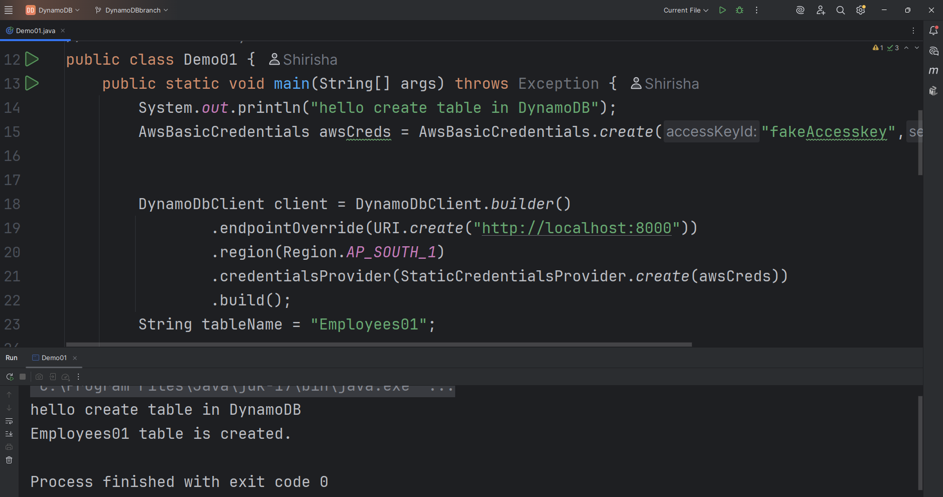

Aws list tables
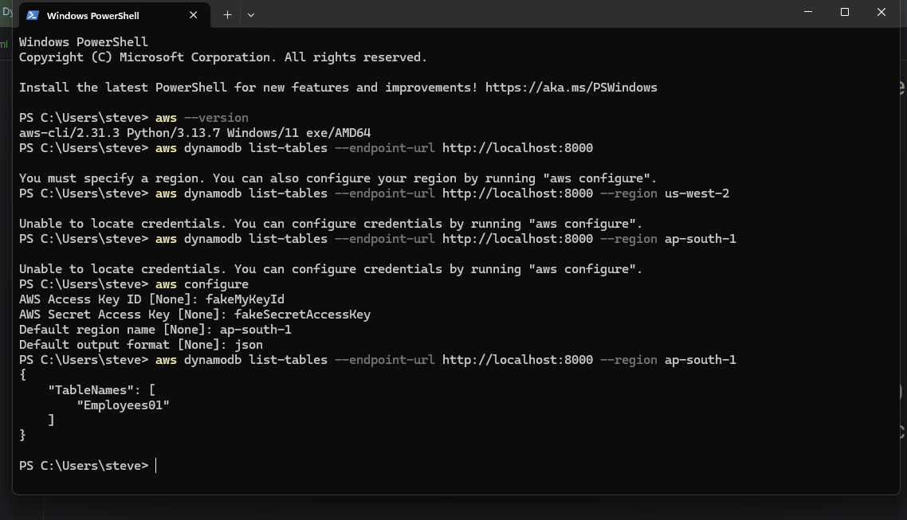

Description of table
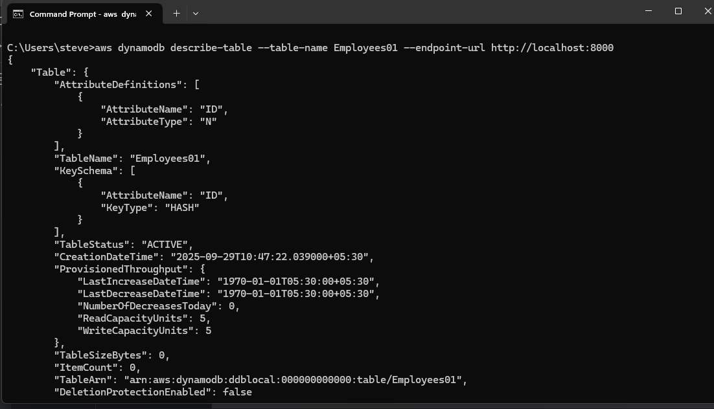

Insert data into table

Create Employee.json in resources folder
Employee.json file
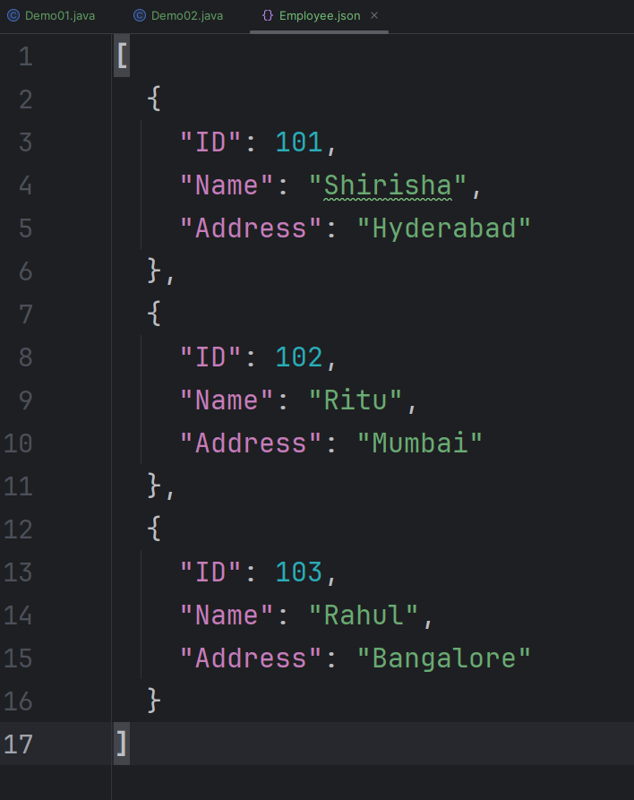

Inserting/loading data into table
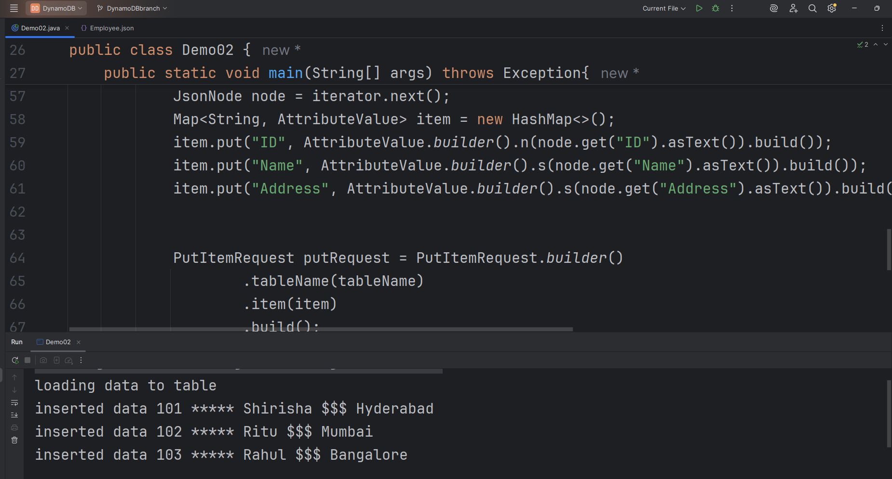

Scan table
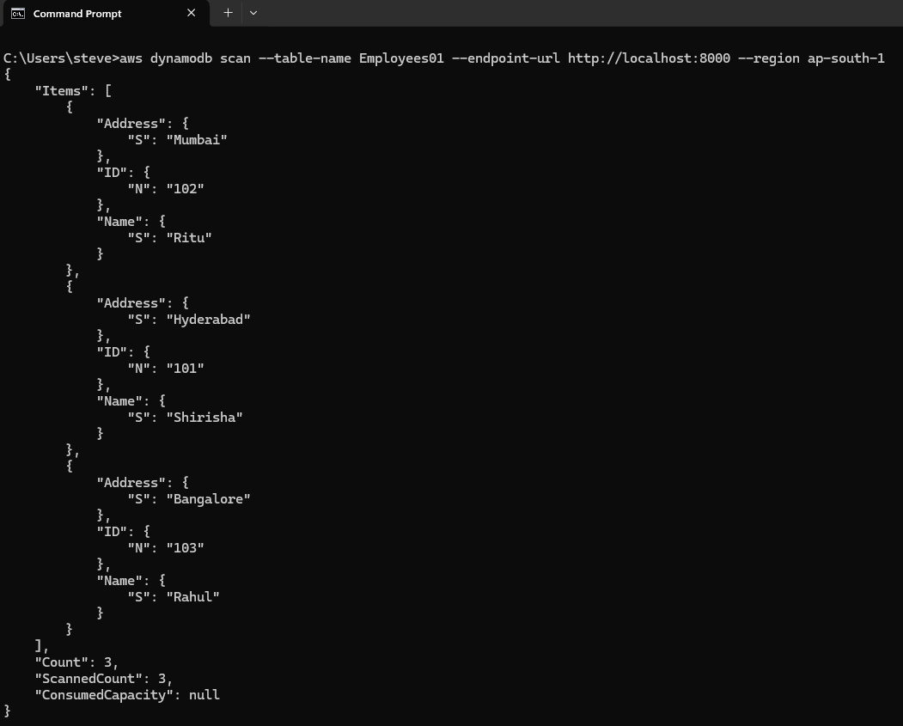

Scanning data from the table
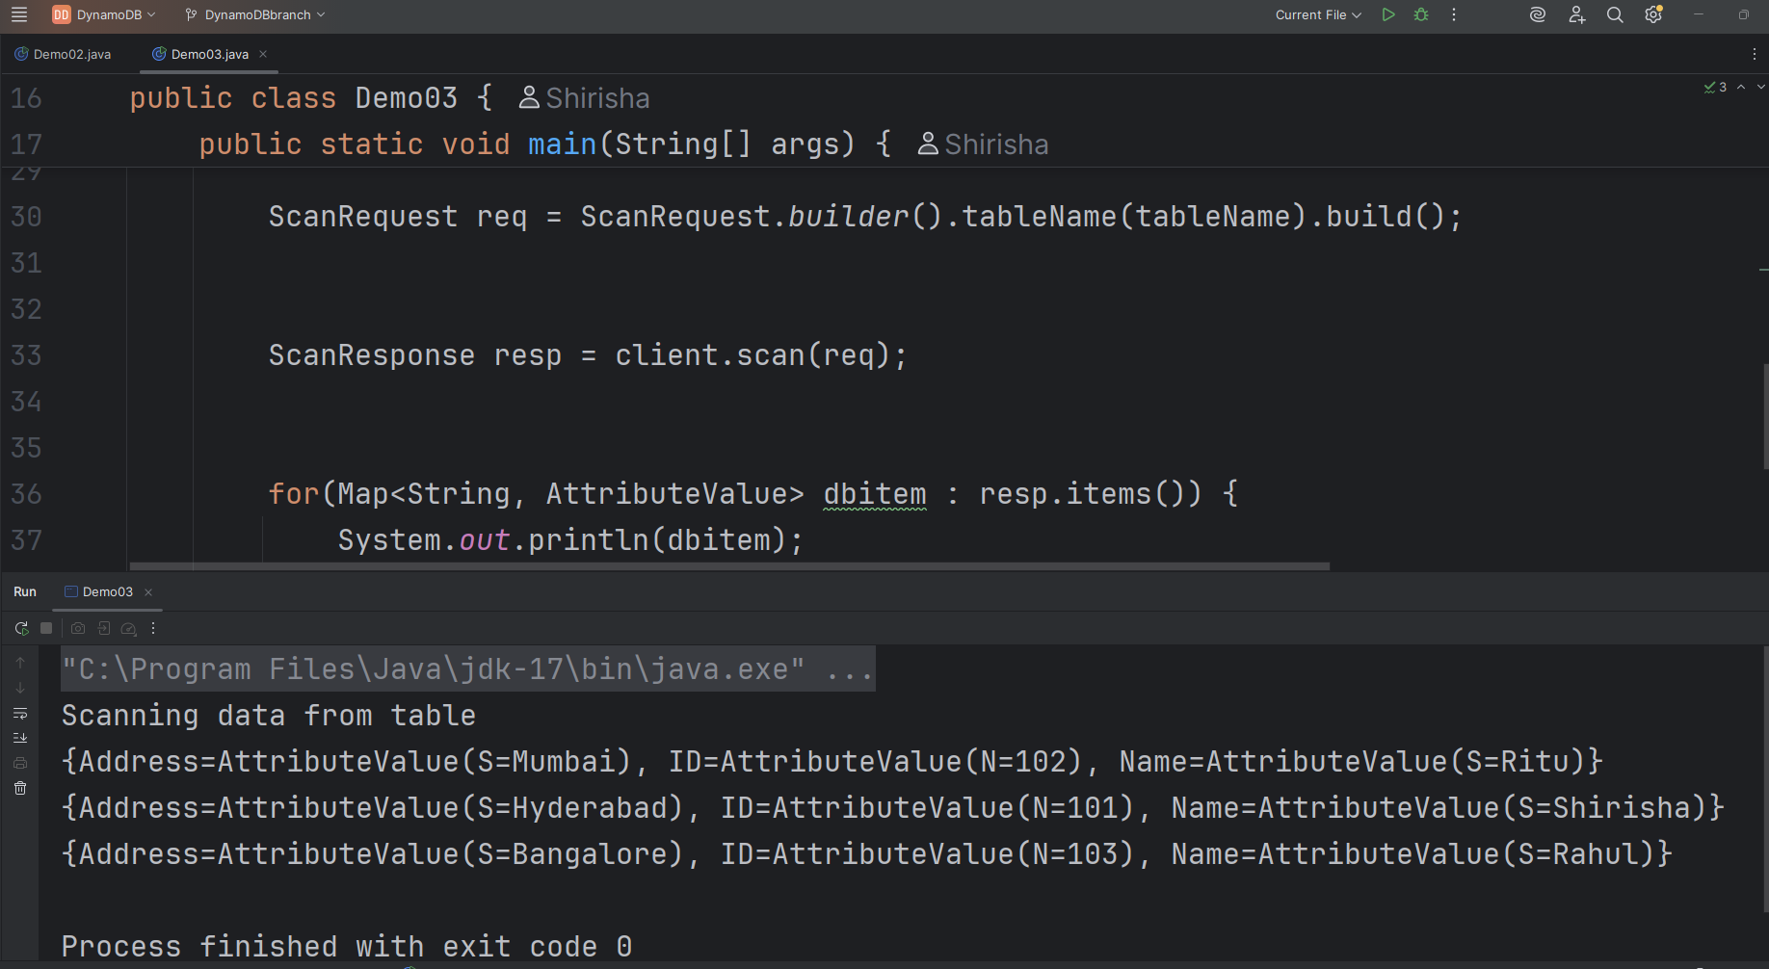
======================================================================HOME TASKS
======================================================================

Task 01
Delete item of id 102 from table
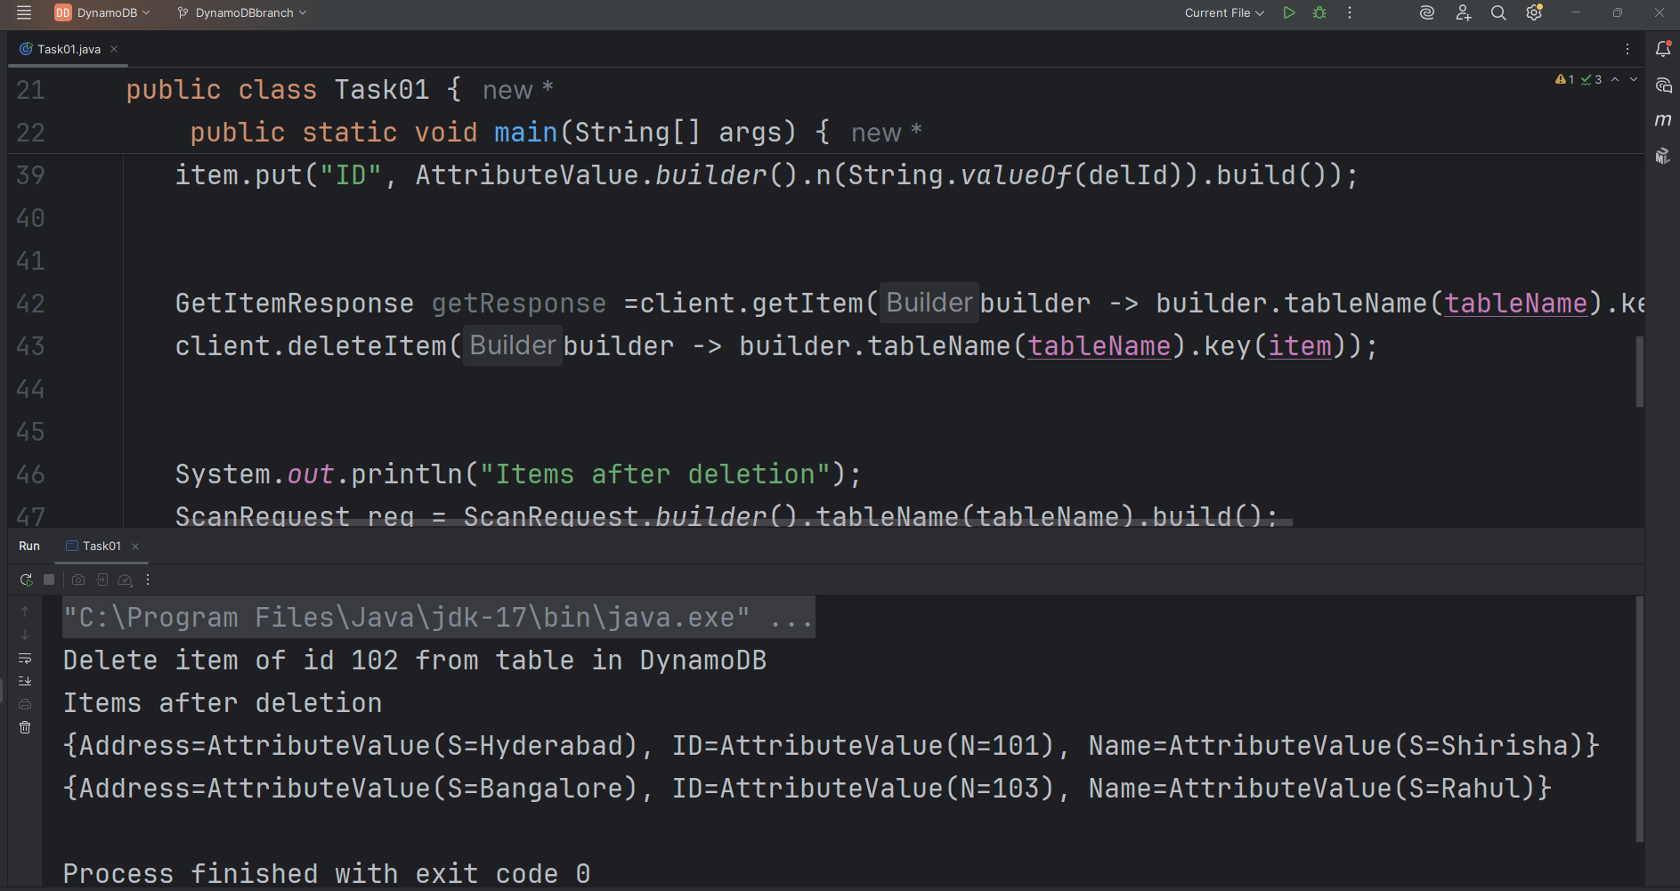

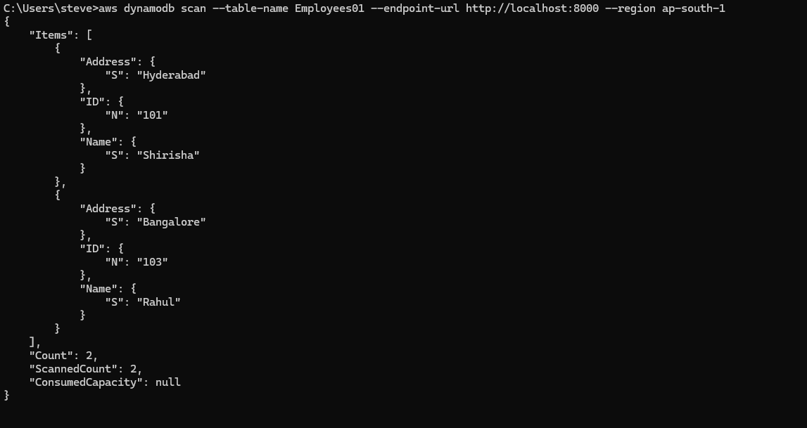

Task 02
Update item in a table
Id=102 item not present hence creates one.
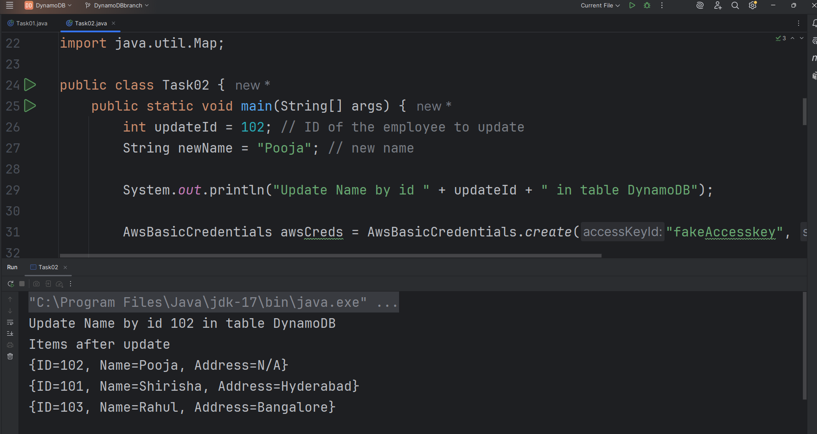

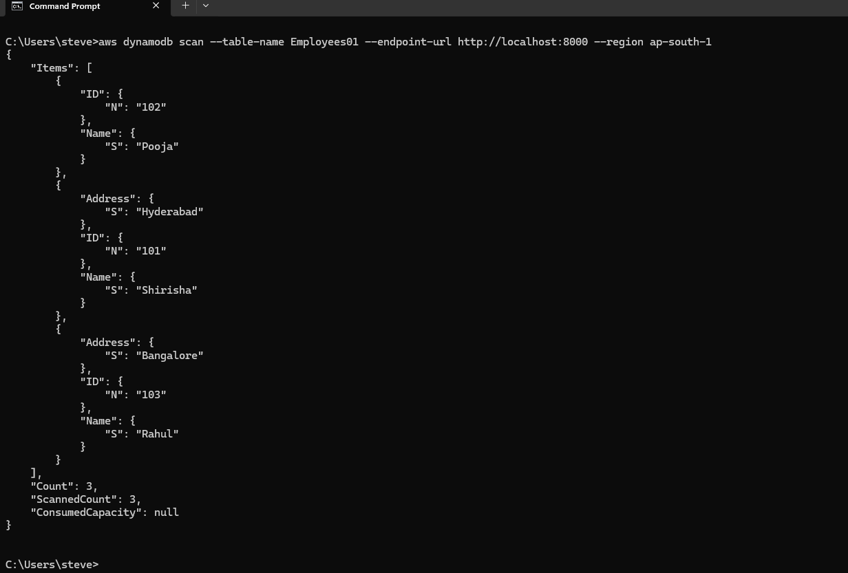

Task 03:
Delete a table
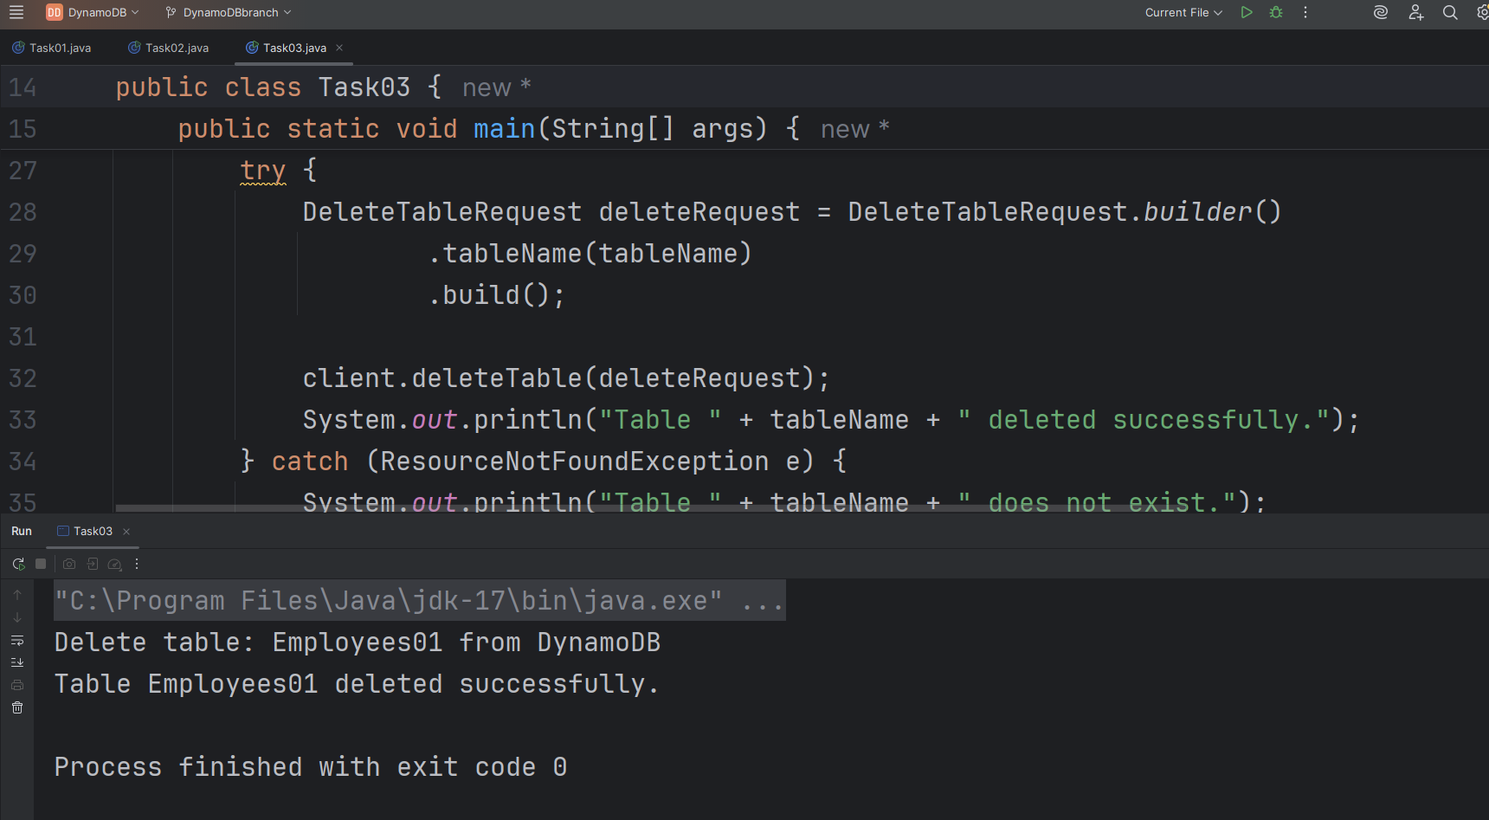

Table Employees01 deleted, no table available
